*Exercise:5*

*Date:12/10/2020*

*AIM:*

*To write a Python program to print missing character to make a string pangram*

*PROGRAM:*

*a=input()*

*a=set(a.strip())*

*a.remove(chr(32))*

*b=”abcdefghijklmnopqrstuvwxyz”*

*b=set(b)*

*b=b.difference(a)*

*b=list(b)*

*b.sort()*

*print(“”.join(b))*

*LINK:*

[*http://103.53.53.18/mod/vpl/forms/edit.php?id=235&userid=1794#*](http://103.53.53.18/mod/vpl/forms/edit.php?id=235&userid=1794)

*OUTPUT:*

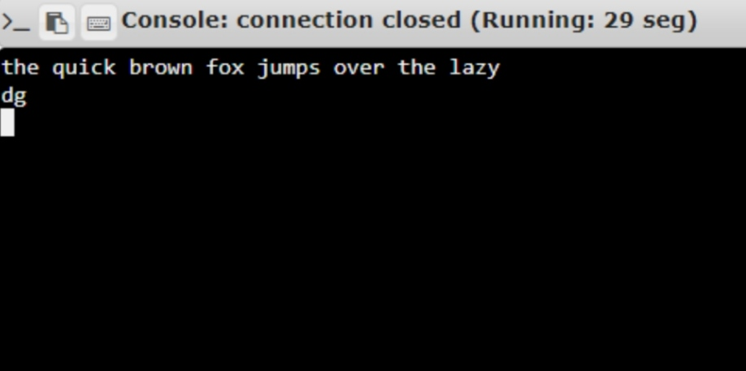

*RESULT:*

*The program to print missing character to make a string pangram is executed and the output is verified.*